DG Interns Hub
Cybersecurity Internship

WEEK 1 ASSIGNMENT
Networking Fundamentals

Objective:
Build a strong foundation in networking and understand how real-world systems communicate.

Prepared by: Pooja G Shivakalimath

Week: 1

1. Introduction to Computer Networking
Computer networking is the interconnection of computers, servers, network devices and other endpoints so that information can be exchanged. Networks allow devices to share data and services locally and across the Internet.
Networking is a core foundation of cybersecurity. Security professionals need to understand normal communication before they can recognize suspicious traffic, unauthorized access, abnormal routes or other security events.

Completed objectives
• Seven OSI layers and their functions
• Four TCP/IP layers and OSI comparison
• HTTP/HTTPS, FTP, DNS and DHCP
• Public/private IP addressing and basic subnetting
• ping, ipconfig and tracert.
• Cisco Packet Tracer device connection, addressing and testing

2. OSI Model – Seven Layers
The Open Systems Interconnection (OSI) model is a seven-layer reference framework for understanding
network communication.
Layer Name Function Real-life example
7.Application Provides network services to applications. Browser using HTTP/HTTPS
6. Presentation Data formatting, encryption and compression. TLS encryption / formatting
5. Session Establishes and manages communication sessions. Application session management
4. Transport End-to-end delivery, segmentation and reliability. TCP communication
3. Network Logical addressing and routing. IP packets through a router
2. Data Link Frames and local delivery using MAC addresses. Ethernet through a switch
1. Physical Transmission of raw bits over a medium. Copper cable signals
Layered communication: data is processed through the layers at the sender and receiver. This makes networking easier to design, troubleshoot and secure.

3.The TCP/IP Model
- The TCP/IP model describes the architecture used by the Internet and modern IP networks.
- Application Layer
  - Purpose: Provides application-level network services and broadly combines OSI upper-layer responsibilities.
  - Examples: HTTP, HTTPS, DNS, FTP, DHCP.
- Transport Layer
  - Purpose: Provides process-to-process communication, reliability, and flow control.
  - Examples: TCP, UDP.
- Internet Layer
  - Purpose: Provides logical addressing and routing.
  - Examples: IPv4/IPv6, ICMP.
- Network Access Layer
  - Purpose: Handles local delivery and physical transmission.
  - Examples: Ethernet, Wi-Fi.
- OSI Model
  - OSI has seven layers and is mainly a conceptual reference model.
- TCP/IP Model
  - TCP/IP has four commonly described layers and maps more directly to protocols used in real IP networks.
- Layer Mapping
  - TCP/IP Application → OSI Application, Presentation, and Session.
  - TCP/IP Transport → OSI Transport.
  - TCP/IP Internet → OSI Network.
  - TCP/IP Network Access → OSI Data Link and Physical.
4. Common Networking Protocols
- Protocols are rules that allow networked systems to communicate consistently.
- HTTP
  - Does: Transfers web resources between clients and servers.
  - Used in: Websites and web applications.
- HTTPS
  - Does: Secures HTTP using TLS.
  - Used in: Secure websites, logins, and APIs.
- FTP
  - Does: Transfers files between a client and server.
  - Used in: File transfer environments.
- DNS
  - Does: Resolves domain names to IP addresses.
  - Used in: Finding services such as google.com.
- DHCP
  - Does: Automatically provides IP configuration.
  - Used in: Home, office, and enterprise networks.
- Security Relevance
  - Protocol knowledge helps cybersecurity learners understand normal traffic and recognize insecure or suspicious communication.
5. IP Addressing and Basic Subnetting
- IP Address
  - A logical address assigned to a network interface.
  - IPv4 addresses contain 32 bits and are written as four decimal octets.
- Private vs Public IP
  - Private IPv4 ranges:
    - 10.0.0.0/8
    - 172.16.0.0/12
    - 192.168.0.0/16
  - Public IP addresses are globally routable on the Internet.
- Subnetting
  - A subnet mask separates the network portion from the host portion.
  - Example: 192.168.1.10 with 255.255.255.0 = 192.168.1.10/24.
- Addressing used in Packet Tracer
  - PC0
    - IPv4: 192.168.1.10
    - Subnet Mask: 255.255.255.0
    - Gateway: 192.168.1.1
  - Router Interface
    - IPv4: 192.168.1.1
    - Subnet Mask: 255.255.255.0
    - Gateway: Not required
6. Practical Task – Network Commands
- The required Windows commands were executed in Command Prompt.
- The screenshots are the user's own practical evidence.
ping google.com
- Tests network reachability to Google.
- Shows the round-trip time for packets.
- The captured output received two replies and showed two timeouts (50% packet loss).
- The result still shows that Google was reachable during part of the test.
- Packet loss can vary depending on network conditions and destination responses.
- 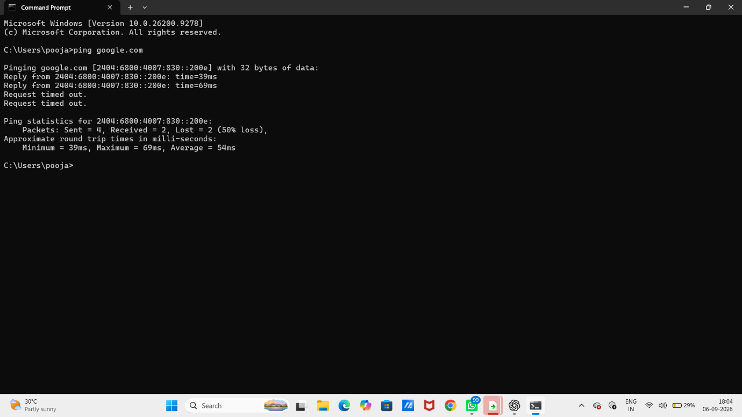

7. Network Configuration and Route Tracing
ipconfig displays local IP configuration, while tracert shows the path toward a destination.
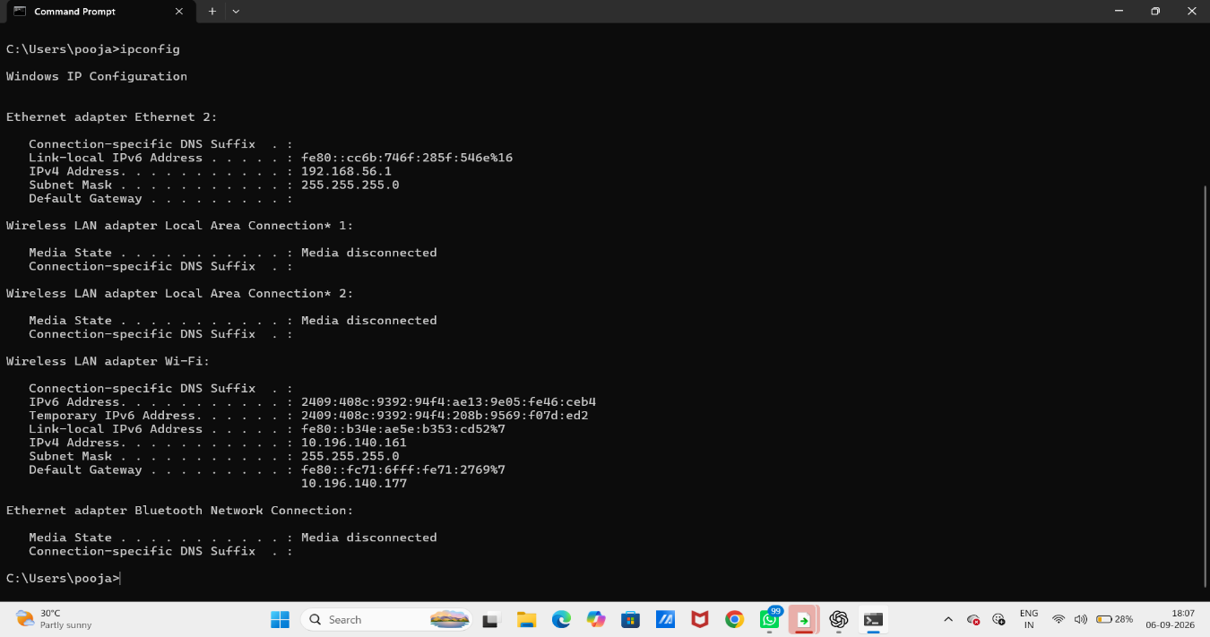
The captured output shows an Ethernet IPv4 address of 192.168.56.1 and a Wi-Fi IPv4 address of 10.196.140.161, with subnet mask 255.255.255.0. The Wi-Fi interface shows gateway 10.196.140.177
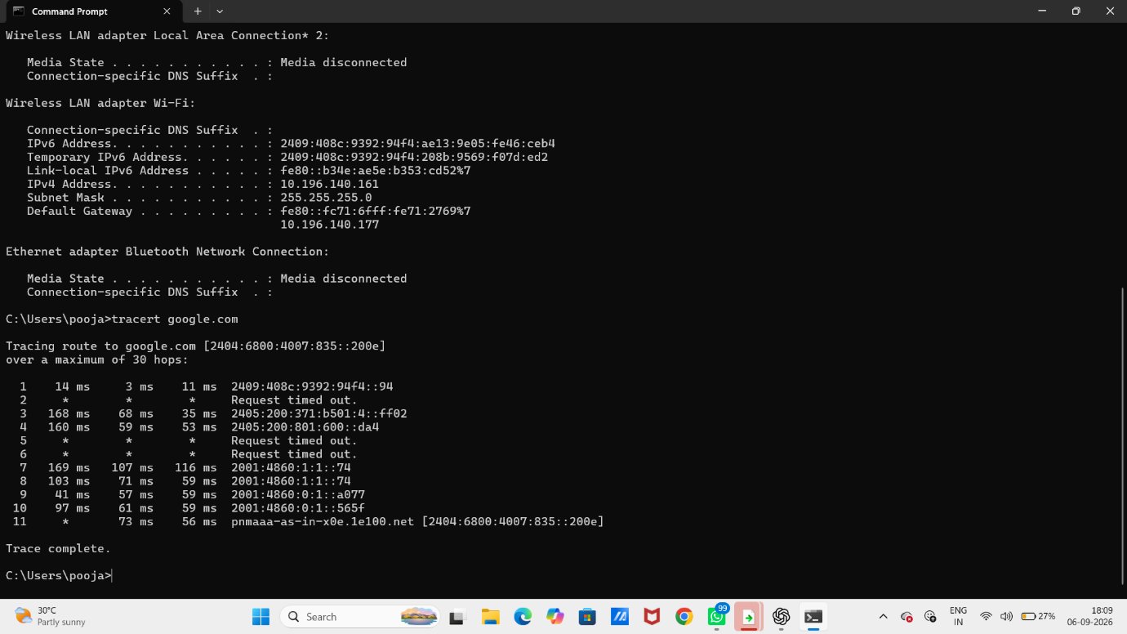 The trace shows multiple hops and some timeout entries before completing.
8. Cisco Packet Tracer – Practical
The simulation used PCs, a 2960-24TT switch and Copper Straight-Through connections. IP addressing and ping were used to test communication. The assignment's final topology also required a router using 192.168.1.1 as the gateway.

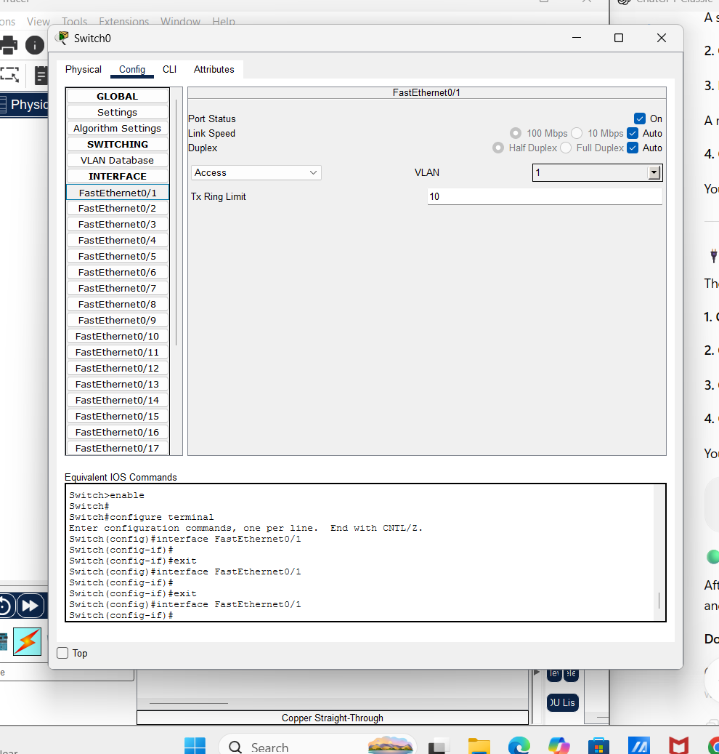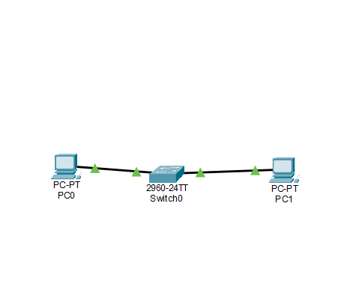
9. Connectivity Test, Results and Conclusion
A Packet Tracer ping test was performed after addressing the simulated devices. The captured test to 192.168.1.20 received three replies after the first request timed out, resulting in 4 packets sent, 3 received and 1 lost (25% loss). This can happen during initial communication while address resolution is being completed.
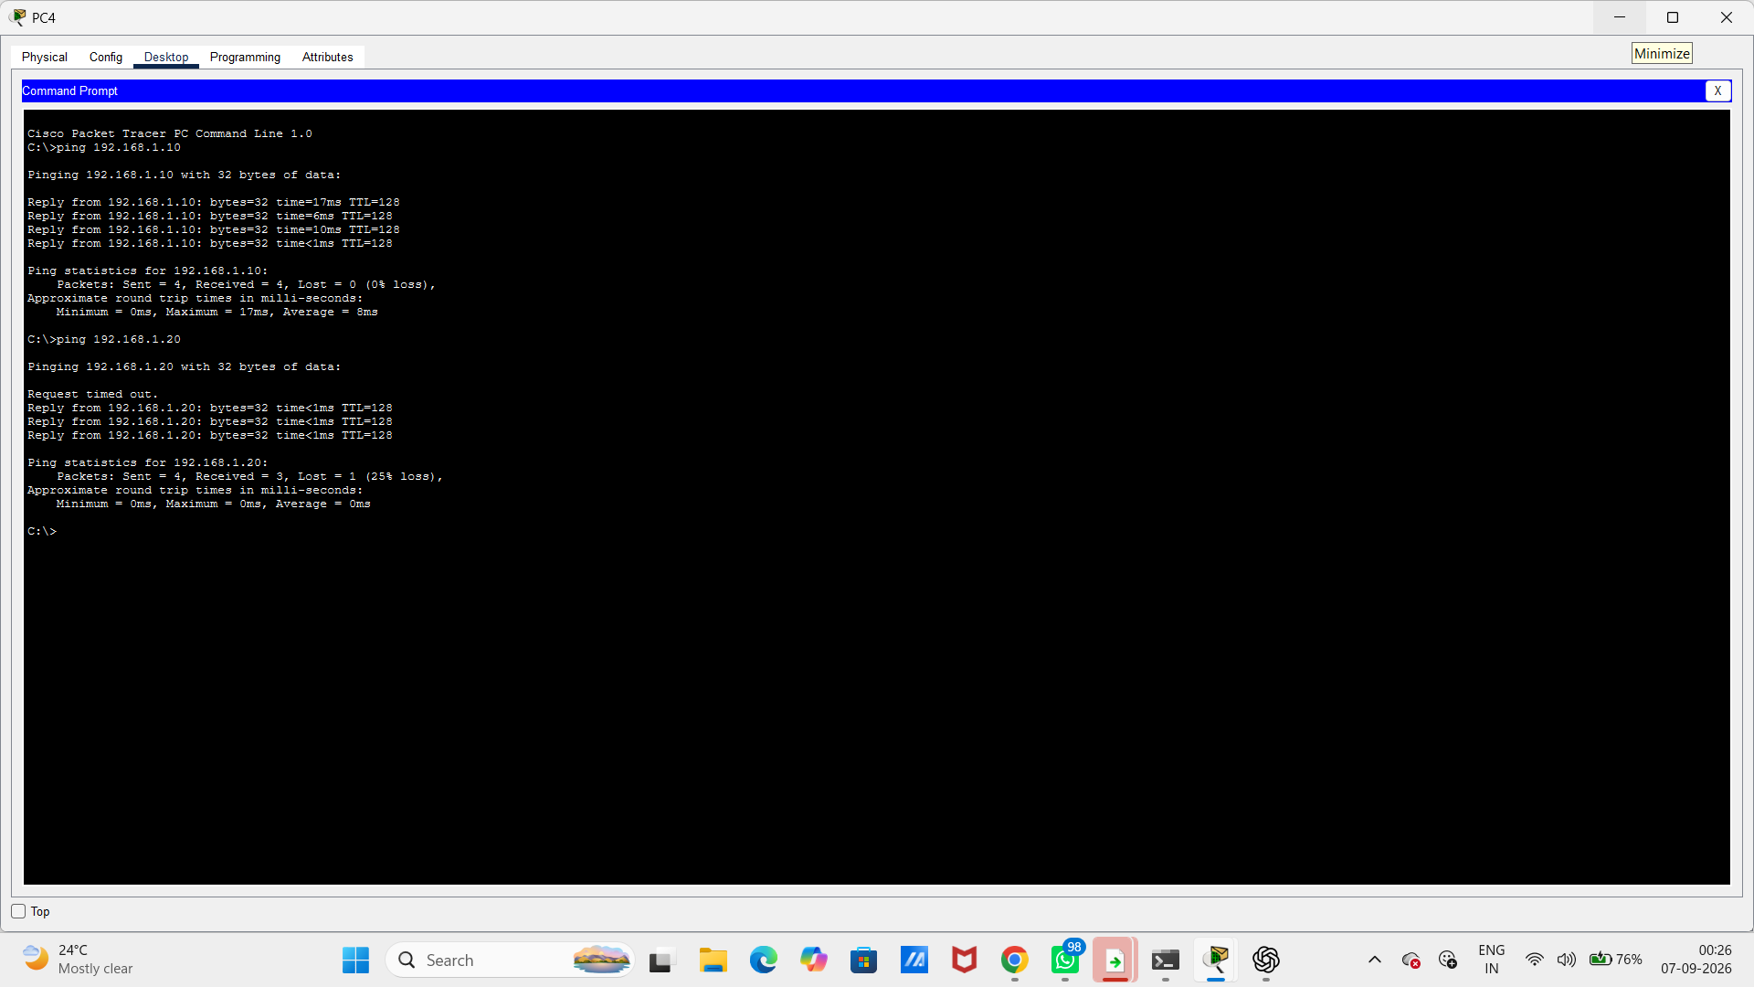
Learning outcomes
• Understood OSI and TCP/IP layers.
• Learned the purpose of major networking protocols.
• Practiced IPv4 addressing and subnetting basics.
• Used ping, ipconfig and tracert.
• Built and tested a simulated switched network.
• Connected networking concepts with cybersecurity fundamentals.
Note: The flowchart image previously sent was intentionally excluded, as requested. The report uses
networking-related screenshots only. The screenshots available here document the practical stages; the
final router topology screenshot should be added later if you want the report to show that final stage
explicitly.

